SYSTEMS & SCALE
MIDDLE SCHOOL

STUDENT PAGES

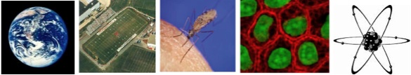

Environmental Literacy Project

Lindsey Mohan & Hui Jin
With help from Jonathon Schramm, Li Zhan, Andy Anderson, Valencia Moses, & Jim Ratcliffe,

Revised February 2009

Embedded Assessments
Please make copies of these student worksheets for the 12 focus students and mail to environmental literacy project.

- Zooming In and Out

- Applying Powers of 10

- What is Air?

- Building Air Molecules

- How Can Machines Work?

- Burning Materials

- Does Burning Release Energy

- Energy-Rich Materials

Name: ________________________________________ Hour: __________

Zooming In and Out

When thinking about different scales we can generally group systems and parts of systems into one of four groups: 1) atomic-molecular (things we cannot see or use a microscope to see; need a really powerful microscope to see), 2) microscopic/cellular (we cannot see with our eyes, but can use a microscope to see), 3) macroscopic (things we can see with our eyes), and 4) large-scale (things that are too large to see with our eyes).

The following is a list of systems included in the Powers of Ten video. Try to sort these systems into one of the four categories described above.

Universe Man or Woman Cell Nucleus United States
Hand Earth Lake Michigan DNA molecule
Skin Carbon Atom Picnic Blanket Galaxy
Capillaries Skin Cell Quarks Chicago
City Park United States White Blood Cell Solar System

- What systems would you see at the atomic/molecular level?

- What systems would you see at the microscopic or cellular level?

- What systems would you see at the macroscopic level?

- What systems would you see at the large-scale level?

- Are there any systems that you are unsure about?

You will watch the Powers of Ten video again. However, this time your teacher will pause the video at each scale, and you will need to think about what appears and disappears when you zoom in or out. You will need to complete the table below, and as you watch the video again, think about the size of different systems and if they match the groups you made on the first page.

What You See When You Zoom In | Starting Point:  What You See | What You See When You Zoom Out
 | City Park
 | Chicago
 | United States
 | Solar System
 | Galaxy
 | Hand
 | Skin
 | Capillaries
 | DNA molecule
 | Carbon Atom

After watching the video again, is there anything you would change from your groups on the first page?

Name: _________________________________________ Hour: ____________

Applying Powers of 10

Now practice using the Powers of 10 to compare sizes of two different systems.

Practice Question:

How much larger is the width of a human hand compared to an average particle of sand?

- How much larger is an average particle of sand compared to an oxygen molecule (O₂)?

- How much smaller is the smallest virus from the largest bacteria?

- How much larger is the biggest piece of sand compared to the smallest piece of sand?

- How much larger is a mosquito compared to a carbon dioxide molecule (CO₂)?

- How much smaller is the smallest plant cell compared to a hand?

- Try to think of two more comparisons using the Powers of 10 chart

Comparison 1:

Comparison 2:

Name: ____________________________________________ Hour: _________

What is Air?

We speak of air as light, "airy," or even as nothing. But what is air made of? Today you will learn more about the different molecules that make up air and have a chance to build these molecules using models.

Air is made of several gas molecules. The composition of air changes slightly from moment to moment and place to place, but approximately 78% is nitrogen (N₂), 21 % is oxygen (O₂), 1% is argon (Ar), and .03% is Carbon Dioxide (CO₂). There are other trace gases in air, such as hydrogen, helium, and neon. Water vapor is also a gas found in air. Water vapor ranges between 0-3% depending on the temperature and humidity.

There are other substances in air, including dirt, germs, bacteria, smoke, and many others. Most substances that you can see in the air, like dust or smoke, are made of solid particles that contain trillions of molecules each. These things are not air.

  - At the macroscopic level, how can you describe air? What things can we see and feel?

  - At the atomic-molecular level, how can you describe air?

  - Can you think of large-scale ways to describe air and how it is used and influenced by living organisms?

4. Can you think of microscopic things that may be found in air?

Name: ___________________________________________ Hour: ______________

Building Air Molecules

Your group will build the gas molecules that make up air and several important molecules for life. In order to do this, you will need to obtain a molecular model kits from your teacher. Before your group begins to build the molecules, you will need to know more about how to “bond” the molecules together.

Part I: Molecular Structure

Molecules are made of atoms bonded together. Today you will build several of the molecules in air and look at how the bonds hold the atoms together.

Single Bonds:
When two atoms share ONE pair of elections, it called a single bond. In water, for example, there are two single bonds.

Double and Triple Bonds:
When a pair of atoms share more than one set of electrons, these are called double and triple bonds. Oxygen and carbon dioxide molecules have double bonds.

Part II: Building Your Molecules

Familiarize yourself with the modeling kit. Open the bag/box and sort the pieces into similar piles. The round wooden pieces with holes in them represent various types of atoms. Each color represents a different element. To build your models you will need to use a color code to represent each type of atom:

Hydrogen- white
Oxygen- red
Carbon- black
Nitrogen- orange

The gray springs represent bonds. When you build molecules correctly, there should be no “empty” holes or bonding points.

Examine one of the hydrogen atoms. How many holes/bond points does it have? ______

How many holes (bonding points) are in the carbon atoms? _______

How many holes (bonding points) are in the oxygen atoms? _______

How many holed (bonding points) are in the nitrogen atoms? _______

Build and diagram the following molecules:

Oxygen (O₂) Water Vapor (H₂O)

WATER MOLECULE

Carbon Dioxide (CO₂) Nitrogen (N₂)

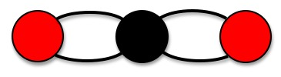

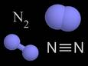

    - Look at your carbon dioxide molecule. Which atoms are bonded to each other in this molecule?

    - Look at your water molecule. Which atoms are bonded to each other in this molecule?

3. Are air molecules matter? Why or why not?

Name:_________________________________________ Hour:___________

How can machines work?

In this activity, you will use the Process Tool to analyze energy transformation in various events. The incoming wavy arrow represents the energy input to the machines. The outgoing wavy arrow represents the energy output from the machines. Please note that the process tool follows the two principles of energy:
- Energy conservation – Energy can transform from one energy form to other energy forms, but the total amount of energy conserves. (Energy cannot be converted into or from matter.)
- Energy degradation – Whenever energy transforms, heat is always released.

1. Radiometer: The radiometer is a light-bulb shaped device with a small weather vane in the middle of it. Place the radiometer under a lamp or sunlight and observe what happens when the light shines on it. Think about what happens inside the radiometer. Please use the process tool to analyze how energy transforms. Fill out the energy input and energy output in the table below.

 | Energy Input | Energy Output
Radiometer spinning

2. Solar Car #1: The solar car has a switch at the bottom. It can either run on battery or use solar cells. Put the switch on “solar”. Observe what happens when the car runs on solar cells. Please use the process tool to analyze how energy transforms. Fill out the energy input and energy output in the table below.

 | Energy Input | Energy Output
Toy car running on solar cells

3. Solar car #2: Put the switch on “battery”. Observe what happens when the car uses the battery. What is the energy input? What is the energy output? Please use the process tool to analyze how energy transforms. Fill out the energy input and energy output in the table below.

 | Energy Input | Energy Output
Toy car running on batteries

4. The Flashlight: In order to make the flashlight work, you will need to squeeze the handle back-and-forth. Observe what happens when you squeeze and release the handle. What is the energy input? What is the energy output? Please use the process tool to analyze how energy transforms. Fill out the energy input and energy output in the table below.

 | Energy Input | Energy Output
Toy car running on solar cells

5. The four events are all about energy transformation. What patterns do you find in the processes of energy transformation?

Name: _____________________________________________ Hour: ________

Burning Materials

1. Please record your observations.

 | Reactants of Combustion |  | Products of Combustion
 | What is the substance that is burning? | Invert the beaker over the flame. What do you observe?  What substance is required to keep the flame burning? | Put a cold glass over the flame, what do you observe?  What substance is released? | There is another product of burning. Do you know what it is?
Burning methane
Burning butane

Burning propane

Burning ethanol

2. You have observed burning different types of fuels. You have also gained some information about different substances involved in burning. What are the patterns?

3. What are the forms of energy involved in these events of burning different materials? What are the evidences of different forms of energy?
Part 2. Explain Combustion by the Process Tool

1. How does matter transform in burning? How does energy transform in burning? Please use the process tool to analyze and then explain how matter and energy transform in the table below.

 | Process | Scale | Energy Input | Energy Output | Matter Input | Matter Output
Burning Methane
Burning Butane
Burning Propane
Burning Ethanol

2. Inside a car engine, the gasoline burns in order to provide energy for the car to run.

What does the car need in order to run? Please use the process tool to analyze and then explain how matter and energy transform as gasoline burns inside the engine in the table below.

 | Process | Scale | Energy Input | Energy Output | Matter Input | Matter Output
Car Running

3. When the car is running, where does the motion energy come from?

4. When the car runs out of gasoline and stops, where has the matter of the gasoline gone?

5. When the car runs out of gasoline and stops, where has the ENERGY of the gasoline gone? Please note that when the car stops running, there is no motion energy.

6. Why do people use gasoline instead of water to run their cars?

7. Is it possible that all the energy of gasoline can be transformed into the energy of car running? Why?

Name:___________________________________________ Hour: ______________

Does Burning Release Energy: Modeling Combustion

Part 1. Why Can Fuels Burn? – Molecules of Fuels

In your groups, you will use molecular model kits to model the process of combustion of different fuel sources. You will model the following four fuels:

1. Burning Methane.
Methane, which takes up about 75% of natural gas, is used as energy source to heat your homes, cook food, or generate electricity.
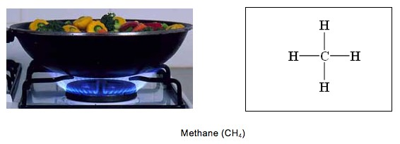

2. Burning butane.
In your classroom, you have butane burner for your chemistry labs. People often use butane lighter to light things, when they are having outdoor activities.
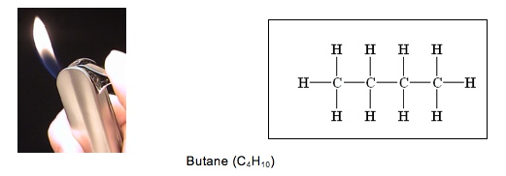

3. Burning propane.
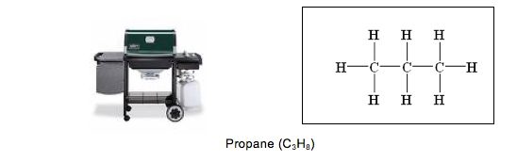
In the summertime, we often use gas grills to cook hamburgers and hot dogs. Many of the grills and camping stoves use propane fuel.

4. Burning ethanol.
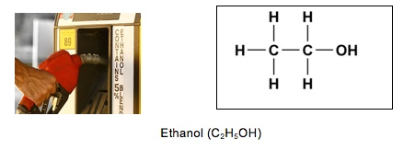
In recent years there has been increasing publicity and support for using ethanol from corn as a fuel source for our automobiles. Currently ethanol is mixed with gasoline and burned by engines in our vehicles.

6. Burning gasoline

Cars run on gasoline. Octane is the major component of gasoline. Usually, octane is combined with another hydrocarbon – heptane (C₇H₁₆) – in order to resist detonation or knock. An 87 gasoline has 87% octane and 13% heptane. Using a higher-level octane will not improve the gas mileage, since the total C-H and C-C bonds contained in the mixture will not change.

Octane (C₈H₁₈)

Questions

1. The article above provides information about molecules of different types of fuels. These molecules all belong to a class of substances – hydrocarbons. What is the similarity among the molecules? Please draw a picture to show the characteristic structure of hydrocarbons.

2. Hydrocarbons are energy-rich materials, because they all contain certain chemical bonds. Please examine the molecules of different types of hydrocarbons. What are the chemical bonds that associated with high-energy?

3. Examine the different molecules. How many bonds can one carbon atom form?

Part 2. Modeling Combustion

1. You have already burned some of these fuels and observed macroscopic changes in matter and energy. You will show what is really happening at the atomic-molecular level as these fuels burn. Matter transformation is described by the chemical equation of combustion as below.

Fuel + oxygen carbon dioxide + water

You will now use your model kits to demonstrate this equation for each fuel source. As you build your models, make sure to complete the tables.
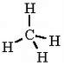
Chemical Change #1: Methane
Methane burns by combining with oxygen in the air to make carbon dioxide and water vapor. One methane molecule reacts with 2 oxygen molecules:

CH₄ + 2 O₂ → CO₂ + 2 H₂O

 | Reactants and Products of the Chemical Change |  |  | Does the substance contain Energy
 | How many carbon atoms does it have? | How many oxygen atoms does it have? | How many hydrogen atoms does it have? | What type of bonds does the substance contain? (C-C, C-H, O-H, C-O, O=O) | Is this substance energy-rich?  (yes or no)
Begin with…
Methane

Oxygen

End with…
Carbon Dioxide

Water

Total amount of different atoms in reactants:
Carbon Atoms: _________ Oxygen Atoms: ___________ Hydrogen Atoms: _________
Total amount of different atoms in products:
Carbon Atoms: ________ Oxygen Atoms: __________ Hydrogen Atoms: _________
Which molecule(s) contain(s) energy? _________.
Chemical Change #2: Propane
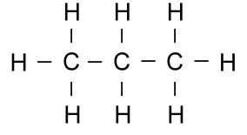
Propane burns by combining with oxygen in the air to make carbon dioxide and water vapor. One propane molecule reacts with 5 oxygen molecules:

C₃H₈ + 5 O₂ → 3 CO₂ + 4 H₂O

 | Reactants and Products of the Chemical Change |  |  | Does the substance contain Energy
 | How many carbon atoms does it have? | How many oxygen atoms does it have? | How many hydrogen atoms does it have? | What type of bonds does the substance contain? (C-C, C-H, O-H, C-O, O=O) | Is this substance energy-rich?  (yes or no)
Begin with…
Propane

Oxygen

End with…
Carbon Dioxide
Water

Total amount of different atoms in reactants:
Carbon Atoms: _________ Oxygen Atoms: __________ Hydrogen Atoms: _________
Total amount of different atoms in products:
Carbon Atoms: _________ Oxygen Atoms: _________ Hydrogen Atoms: _________
Which molecule(s) contain(s) energy? _________.
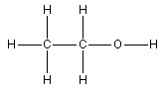
Chemical Change #3: Ethanol
Ethanol burns by combining with oxygen in the air to make carbon dioxide and water vapor. One ethanol molecule reacts with 3 oxygen molecules:

C₂H₅OH + 3 O₂ → 2 CO₂ + 3 H₂O

 | Reactants and Products of the Chemical Change |  |  | Does the substance contain Energy
 | How many carbon atoms does it have? | How many oxygen atoms does it have? | How many hydrogen atoms does it have? | What type of bonds does the substance contain? (C-C, C-H, O-H, C-O, O=O) | Is this substance energy-rich?  (yes or no)
Begin with…
Ethanol

Oxygen

End with…
Carbon Dioxide
Water

Total amount of different atoms in reactants:
Carbon Atoms: _________ Oxygen Atoms: __________ Hydrogen Atoms: _________
Total amount of different atoms in products:
Carbon Atoms: _________ Oxygen Atoms: __________ Hydrogen Atoms: _________

Which molecule(s) contain(s) energy? _________.
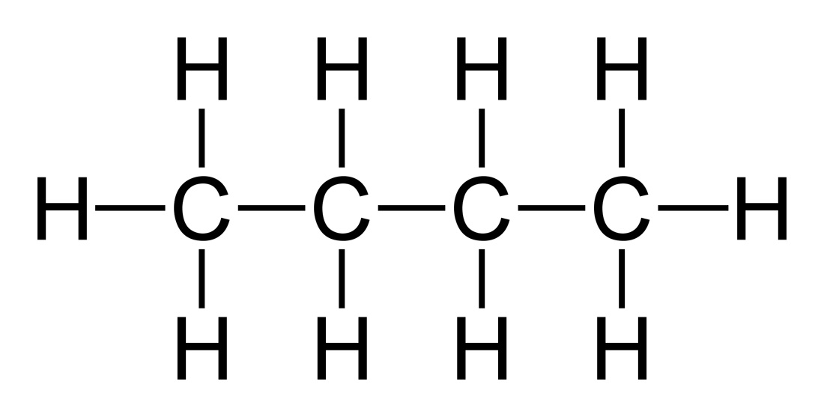
Chemical Change #4: Butane
Butane burns by combining with oxygen in the air to make carbon dioxide and water vapor. Two butane molecules react with 13 oxygen molecules:

2 C₄H₁₀ + 13 O₂ → 8 CO₂ + 10 H₂O

 | Reactants and Products of the Chemical Change |  |  | Does the substance contain Energy
 | How many carbon atoms does it have? | How many oxygen atoms does it have? | How many hydrogen atoms does it have? | What type of bonds does the substance contain? (C-C, C-H, O-H, C-O, O=O) | Is this substance energy-rich?  (yes or no)
Begin with…
Butane

Oxygen

End with…
Carbon Dioxide
Water

Total amount of different atoms in reactants:
Carbon Atoms: _________ Oxygen Atoms: __________ Hydrogen Atoms: ________
Total amount of different atoms in products:
Carbon Atoms: _________ Oxygen Atoms: __________ Hydrogen Atoms: ________
Which molecule(s) contain(s) energy? _________.
Summary Questions:

1. Each carbon dioxide molecule that is given off during combustion contains 1 carbon. Where was this carbon atom before it was in the carbon dioxide molecule?

2. Combustion is a process where energy-rich substances react with oxygen to make substances without high-energy bonds. What happens to energy in this process if it is no longer found as chemical energy?

3. Compare the reactants and products of combustion. Are there high-energy bonds (C-C and C-H) contained in reactants? Are there high-energy bonds contained in the products?

4. You have made models of energy-rich materials that we burn. How do the molecules change when they are burned? What happens to the atoms?

5. Please use two equations to show how matter transforms and how energy transforms during combustion. Then answer the following questions:

a) Compare the amount of different types of atoms before and after the chemical change. What pattern do you find?

b) Does the total amount of energy change after the chemical reaction?

QUESTION YOU STILL HAVE:

Do you still have questions about how matter or energy change during combustion? In the space below, write about new things you learned about combustion, or questions you have that were not answered during the previous activities.

Name:________________________________________ Hour: ___________

Energy-Rich Materials

N≡N O=O O=C=O O-H-O
Nitrogen Oxygen Carbon Dioxide Water

1. Look at the molecules that make up most of our air. Do you think these molecules are sources of chemical energy? Explain why or why not.

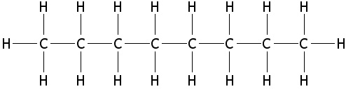

2. a. This is an octane molecule found in gasoline. Is this molecule similar or different from the fuel molecules you built in the previous lesson? Explain why it is similar or different.

b. Which of the molecules in the reading (glucose, propane, lipid) is most similar to the octane molecule? What might this mean in terms of energy storage for plant and animal cells?

Look back at the all the molecules you built using your model kits and other molecules you read about today. Which molecules have chemical energy and which do not? Complete the table below.

Which molecules have chemical energy? | Which are NOT sources of chemical energy?

Summary Questions:

1. What makes the molecules with chemical energy similar?

2. How are molecules with chemical energy different from the molecules without chemical energy?

